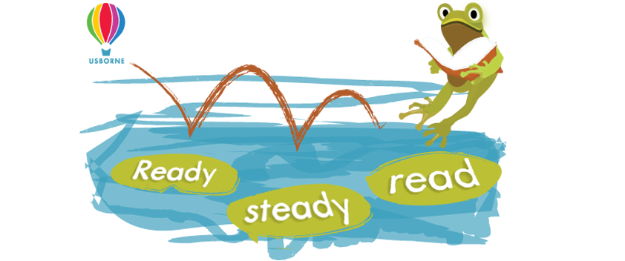
Sponsorship Form
Child’s Name ……………………………………………………… Class …………………………………………………….
Name | Contact Details | Sponsorship  (per minute or total) | Collected | TOTAL
Reading Log
Date | Books/Item Read | Minutes Read | TOTAL
Monday 31st May
Tuesday 1st June
Wednesday 2nd June
Thursday 3rd June
Friday 4th June
Saturday 5th June
Sunday 6th June
Monday 7th June
Tuesday 8th June
Wednesday 9th June

Please return all sponsor money (cash only) by Friday 11th June 2021
Please don’t hesitate to ask if you would like any help or more information

